Frequent fire in northern California chaparral reduces post-fire shrub regeneration and native plant diversity

Grupenhoff, A1 & Safford, HD1,2

1Department of Environmental Science and Police, University of California, 1 Shields Ave, Davis, California 95616, USA

2Vibrant Planet, Incline Village, Nevada, USA

# Abstract

Like much of the western US, fire is crucial for maintaining species diversity and resilience in chaparral-dominated shrublands. Chaparral historically experienced high intensity burns with long intervals between fires. Fire frequency, however, has increased exponentially in this ecosystem with the rise of urbanization and an extended fire season. This departure from historical patterns has severe implications for biodiversity, leading to exotic invasion and type conversion of shrubland to grassland. While this phenomenon has been extensively studied in southern California, there is limited understanding of the timing and mechanisms of shrubland type conversion in northern California. This study investigates the impact of fire frequency on the composition and abundance of herbaceous and woody species in the Interior Coast Range of northern California, one of the most frequently burned areas in the state. We surveyed fifty-four 250-m2 plots to assess changes in plant community composition and postfire regeneration of chaparral shrubs across a wide range of fire frequencies, including plots that have burned up to six times in the past 30 years. Our findings reveal that high fire frequency significantly reduces post-fire native woody regeneration, with obligate seeding species experiencing a 99% reduction and facultative species showing an 83% reduction in regeneration in the most frequently burned plots. Moreover, fire frequency decreases the proportion of native species cover by 12% and richness and Shannon diversity both by 4%. Consequently, areas with higher fire recurrence exhibited a more homogeneous landscape, dominated by similar non-native species.

***Keywords:*** *chaparral, fire frequency, post-fire regeneration, species diversity*

# Introduction

Fire is vital for maintaining biodiversity in many fire-adapted ecosystems across the western US, but interactions between anthropogenic drivers such as rapid climate warming, disturbance regime interventions, and land use change are shifting the spatial-temporal pattern of fire (hereafter, fire regime) in this region. In chaparral systems, we are seeing a hotter and drier climate leading to more extreme fire weather and urbanization increasing the number of human ignitions [(Keeley and Fotheringham 2001, Abatzoglou and Williams 2016)](https://www.zotero.org/google-docs/?sUJdAK). These changes in climate and ignitions have altered natural fire regimes across the region, posing serious risks to chaparral shrublands (Keeley and Brennan 2012, Syphard et al. 2019, Park et al. 2018).

Because the shrub canopy is short and mostly connected to surface fuels, California chaparral mostly burns at high intensity [(Keeley and Safford 2016)](https://www.zotero.org/google-docs/?zA2JIj). Chaparral vegetation is adapted to moderately infrequent fire, with paleodata and modeling studies suggesting an optimal fire return interval range between 30 and 90 years [(Van de Water and Safford 2011)](https://www.zotero.org/google-docs/?ibOaNj). In the last 30-40 years, fire frequency has exponentially increased in many areas dominated by chaparral, driven by urban expansion and increased anthropogenic ignitions, and interactions with invasive annual grasses, climate warming, and recurrent droughts [(Syphard et al. 2006, 2019, Park et al. 2018)](https://www.zotero.org/google-docs/?0VQMdY). Studies have examined the effects of increased fire frequency in southern California, showing that large areas of lowland and lower montane chaparral have been converted to exotic grassland [(D’Antonio and Vitousek 1992, Keeley and Brennan 2012, Park et al. 2018, Syphard et al. 2019)](https://www.zotero.org/google-docs/?sq0k3q).

Many plants adapted to fire-prone ecosystems have traits that allow them to survive and regrow after fire or to rapidly recolonize burned areas [(He et al. 2019)](https://www.zotero.org/google-docs/?KRFe9x). Postfire recovery includes factors such as regrowth, reproduction, dispersal, germination, and establishment, all of which are mediated by how plant traits interact with fire severity [(McLauchlan et al. 2020)](https://www.zotero.org/google-docs/?R5A2x3). Specifically, postfire recovery in chaparral involves regeneration initiated by germination of the dormant seed bank, resprouting from lignotubers and other vegetative structures, or wind dispersal. Native woody species are commonly divided into obligate seeders (species incapable of vegetative regeneration and which germinate from the dormant seed bank in the first postfire year), obligate resprouters (which lack a dormant seed bank but regenerate vegetatively), and facultative seeders (which have post-fire germination coupled with resprouting). Native species in these systems do not usually reestablish by dispersal from outside the burn perimeter.

Uncharacteristically short fire return intervals threaten chaparral resilience and persistence by eliminating species without adaptations to short fire return intervals. Increased fire frequency may induce substantial seed mortality for obligate seeders since these species often require a decade or more to replenish the seed bank [(Zedler et al. 1983, Jacobsen et al. 2004)](https://www.zotero.org/google-docs/?t4qNEZ). Some studies have also shown that even resprouting chaparral will be eliminated if fire is frequent enough [(Haidinger and Keeley 1993, Keeley and Brennan 2012)](https://www.zotero.org/google-docs/?9QD3Xi). A change in fire history patterns may have more complex implications on the vegetative community and can ultimately lead to type conversion to a different community [(Pausas et al. 2004, Syphard et al. 2019)](https://www.zotero.org/google-docs/?60KJ8x).

Shifts in species composition and type conversion to nonnative grassland have large-scale implications for ecosystem resilience, regional and local biodiversity, and ecosystem services such as primary production, carbon sequestration, nutrient cycling, pollination, erosion mitigation, and habitat provision [(Rundel 2018, Underwood et al. 2018)](https://www.zotero.org/google-docs/?TbFZeF). As such, understanding the nuanced effects of fire recurrence on biodiversity and species composition is necessary for understanding future trajectories of chaparral type conversion. The direct impacts of climate change can also lead to changes in vegetation communities. However, changing fire regimes can accelerate vegetation change, and in some instances, may be even more important than direct changes as a result of climate [(Flannigan et al. 2000, Pausas et al. 2004)](https://www.zotero.org/google-docs/?xNe5jb). To date, no study has examined these effects at sites that have burned more than three times in the past few decades. Additionally, only a handful of studies have focused on the Coast Range of northern California, one of the most frequently burned locations in the whole state.

Our study took place in the footprint of the 2020 Hennessy Fire. The landscape burned by the Hennessy has a rich fire history. 38% of the Hennessy Fire had burned in the previous 10 years, the highest proportion of any 2020 fire, and more than 50% had burned at least once in the last 20 years [(Safford et al. 2022)](https://www.zotero.org/google-docs/?GJPYHG). Some areas in the Putah and Cache Creek drainages had burned 6 times since 1985, and up to 4 times in the previous 7 years, which makes these areas among the most frequently burned in all of California. Despite the high frequency of recent fires in our study region, till now no one has examined how such high fire frequencies might be impacting ecological conditions in chaparral vegetation in northern California. Indeed, no published studies in California have evaluated the impacts of five or more fires on chaparral resilience. To understand when northern California chaparral communities lose resilience to invasion, we asked two primary questions: 1) How does fire frequency affect the diversity and cover of native and non-native species and 2) What are the consequences of higher burn frequency on shrub seedling establishment and resprouting success. Based on results from studies in southern California, we hypothesized (1) a reduction in species diversity and local richness in areas with more than 2 short interval fires and (2) decreased native shrub regeneration and resprout growth of native shrubs. Specifically, we hypothesized higher burn frequency would lead to a reduction in the probability of obligate and facultative seedling regeneration after 2 short interval fires (2a) and a reduction in resprout growth of facultative species after 3 short interval fires (2b).

# Methods

***Study Site:***

The study was conducted in the Interior Coast Range of California which exhibits a diverse mosaic of chaparral, oak woodland, and grassland. Chaparral vegetation consists of drought-tolerant, sclerophyllous plants. Our study focused on *Adenostoma fasciculatum* (chamise) chaparral and mixed chaparral stands. Pure stands of chamise-dominated chaparral occur on sandstone substrates on xeric exposures with shallow soils, while mixed chaparral stands occur on more mesic exposures with deeper soils and include chamise as well as other co-dominant species such as *Ceanothus sp., Heteromeles arbutifolia, Arctostaphylos sp.*, and *Quercus berberidifolia.*

Historic fire-return intervals in California chaparral have been estimated between 30-90 years [(Van de Water and Safford 2011)](https://www.zotero.org/google-docs/?FekROZ) and the natural ignition sources prior to European colonization were lightning and burning by Indigenous people who relied on chaparral plant communities for foods, medicines, and ceremonial items [(Anderson and Keeley 2018)](https://www.zotero.org/google-docs/?KixXyJ). Humans are still the primary ignition source in this landscape due to accidents from power lines, vehicles, and campfires, in contrast with the planned ignitions by Native people to maintain the distribution of chaparral [(Syphard and Keeley 2015, Anderson and Keeley 2018)](https://www.zotero.org/google-docs/?4IJyrK). Alteration of the natural fire regime can lead to the transition from chaparral to oak woodland or grassland. In some cases, chaparral can transition to woodland or forest after very long intervals without fire [(Callaway and Davis 1993, Safford et al. 2021)](https://www.zotero.org/google-docs/?8aToyj). The primary successional pathway we see today, however, is a transition to disturbance-tolerant non-native grassland due to an increase in fire frequency [(Zedler et al. 1983, Keeley and Fotheringham 2003, Syphard et al. 2019)](https://www.zotero.org/google-docs/?RNLvSb).

We sampled post-fire chaparral plant communities after the 2020 LNU Lightning Complex Fire, which was one of the largest fires in California history, burning 124,000 hectares in Napa, Yolo, Solano, and Lake Counties [(Safford et al. 2022)](https://www.zotero.org/google-docs/?8DnYAS). We focused on the area burned in the Hennessy Fire, which ignited by lightning on August 17th and was extinguished in early October. In total, 54 plots were sampled at Quail Ridge UC Natural Reserve (38°30’ N, 122°08’ W), Cold Canyon UC Natural Reserve (38°30’ N, 122°06’ W), Cache Creek Regional Park (38°54’ N, 122°18’ W), and Bobcat Ranch Audubon Reserve (38°31’ N, 122°04’ W) (Fig. 1). All sites are between 260-540 m elevation and occur on more fertile sandstone substrates, experiencing a Mediterranean climate with annual average of 630-760 mm precipitation and mean temperatures of 16°C in the summer months (30-year average, 4-km-resolution, PRISM Climate Group 2022).

This area has a variable fire history, ranging from never burned to six prior burns in the past 30 years (Table 1). Plot locations were stratified across a fire frequency gradient and aspect, with an equal number of plots on north and south-facing slopes.GIS layers from the USDA Forest Service were used to extract the date of origin and fire size for fires that occurred during the past 30 years. Fire frequency was calculated using the California Fire Return Interval Departure database. Since these fire perimeters generally ignore unburned patches within fires that are less than hundreds of acres in size, we used Google Earth historical imagery to examine the landscape for unburned patches after each fire. Heat load index was calculated for each transect using aspect and slope to account for the amount of solar radiation received [(McCune and Keon 2002)](https://www.zotero.org/google-docs/?p53B4A). Precipitation and temperature point estimates were extracted for each transect using the 4 km resolution PRISM dataset (PRISM Climate Group 2022).

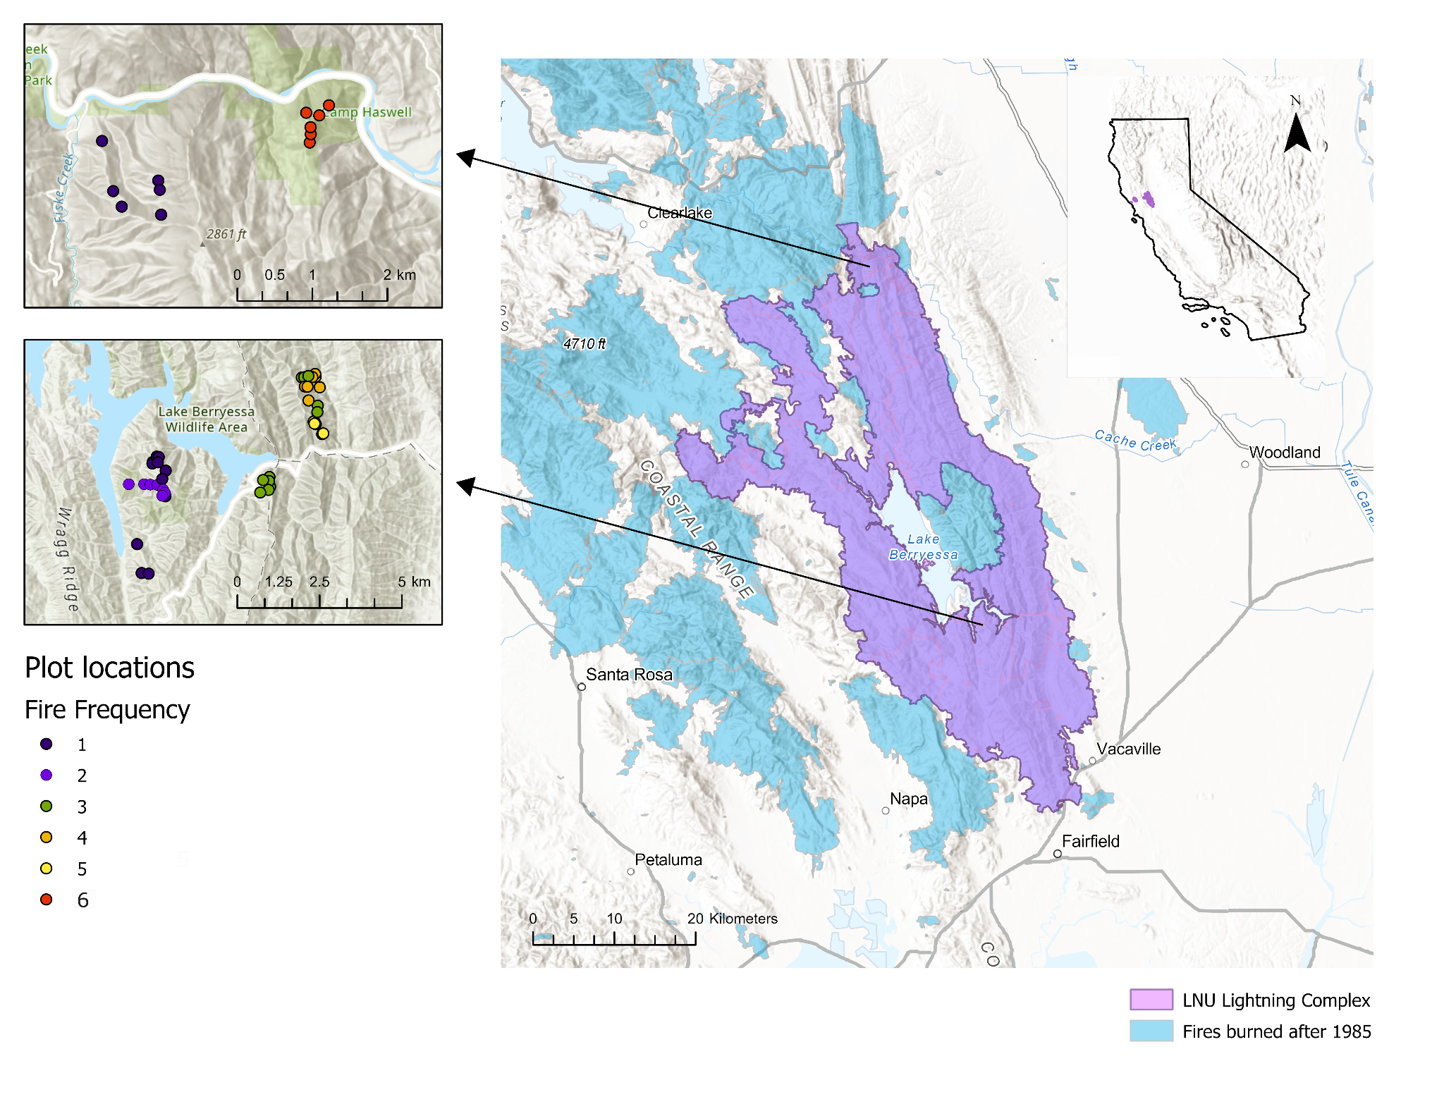

*Fig. 1. Map of LNU Lightning complex (purple polygon) with locations of prior fires burned since 1985 (light blue polygons). The figures to the left show plot locations, which were distributed across a fire frequency gradient of 1 total burn (blue) up to 6 total burns in the past 30 years (red).*

Table 1: Study sites across the LNU Lightning Complex

|  |  |  |  |  |
| --- | --- | --- | --- | --- |
| Site | Jurisdiction | Fire History (since 1980) | Shortest interval between fire | Fire frequency (since 1985) |
| Bobcat Ranch | Audubon Canyon Ranch | 2020 (Hennessey), 2018 (County), 2016 (Cold), 2014 (Monticello), 2007 (Braye) | 2 | 3,4,5 |
| Quail Ridge | UC Natural Reserve | 2020 (Hennessey), 2005 (Pleasure) | 15 | 1,2 |
| Cold Canyon | UC Natural Reserve | 2020 (Hennessey), 2015 (Wragg),  Miller (1988) | 5 | 3 |
| Cache Creek | BLM | 2020 (Hennessey), 2012 (sixteen complex), 2004 (Rumsey), 2002 (Sixteen), 1999 (Rumsey), 1987 (Haswell) | 2 | 1,6 |

***Sampling Design & Processing:***

At each of the 54 plots, 50 x 5-m belt transects were established following [Safford and Harrison (2004) and Werner et al. (2022)](https://www.zotero.org/google-docs/?rwSS6l). Sites were visited in the spring of 2021 and 2022. All plant species were recorded within the entire 250-m2 transect to measure the overall richness of native and exotic plant species. Five 1-m2 quadrats were sampled at 10-m intervals along the transect line, measuring: the percent cover of all native and exotic species; number and height of shrub seedlings; resprout height; percent cover of rock, bare soil, and litter; and litter depth. All variables collected at the 1-m2 scale were averaged to give a transect-level value. Plant life history data for each species were obtained from the USDA Forest Service Fire Effects Information System or the University of California Jepson Herbarium. Species were classified by origin (native, non-native), lifeform (tree, shrub, forb, graminoid, fern), and fire regeneration strategy (obligate seeder (OS), facultative seeder (FS), obligate resprouter (OR)) using the [Raunkiaer (1934)](https://www.zotero.org/google-docs/?13bmW0) classification system. The proportion of native species cover, richness, and diversity were calculated at each transect each year (2021 & 2022). We calculated the proportion of native plant cover in each plot as the total native cover/(total native cover + total exotic cover). Additionally, we calculated the proportion of local species richness (calculated as the mean number of species per 250 m2 plot) and the proportion of Shannon-Wiener diversity (which gives weight to rare species) using the vegan package in R [(R Core Team 2021, Oksanen et al. 2023)](https://www.zotero.org/google-docs/?0DygHQ).

Fire severity was estimated in each belt transect by measuring the stem diameter (1 cm from the terminus) of four stems from a randomly chosen *Adenostoma fasciculatum* (chamise) individual rooted in or adjacent to each quadrat [(Perez and Moreno 1998)](https://www.zotero.org/google-docs/?wruRZi). Additionally, five more individuals were measured at the entire 250m2 transect scale. In cases when chamise was not present we used *Heteromeles arbutifolia* or *Quercus berberidifolia* individuals. We measured heterogeneity in fire severity within each belt transect by calculating the coefficient of variation for the five quadrats within a transect.

***Statistical analyses***

*Species cover, diversity, and composition (H1)*

Bayesian generalized linear mixed models were used to investigate the interaction between fire frequency on the proportion of native species cover, richness, and diversity for both survey years using a Beta Binomial likelihood (Equation 1), which accommodates values between 0 and 1. To determine which environmental covariates to add to the model, we used the expected log pointwise predictive density (ELPD) to measure leave-one-out cross-validation for our goodness of fit measure. The covariates that we evaluated were fire frequency (numBurn), mean annual precipitation, mean annual temperature, heat load index, and aspect. We verified that independent variables were not highly correlated using the Spearman correlation coefficient (Supplemental Fig. 1). We first fit the proportion of native species cover with each individual predictor separately and added significant predictors in order of ELPD to determine whether they significantly increased ELPD of the resulting model. Non-metric multidimensional scaling (NMDS) was used to visualize compositional differences between areas with variable fire recurrence as a part of the vegan package in R [(R Core Team 2021, Oksanen et al. 2023)](https://www.zotero.org/google-docs/?9WJaza). This ordination uses rank-order correlation and Bray-Curtis dissimilarities to model the differences among treatments based on species composition and abundance of all plant species.

*Equation 1:*

$$prop.nativecover_{i,j} \sim Beta(μ_{i,j },ϕ)$$

$$logit(μ_{i,j }) = α + β_{numBurn}numBurn +β_{numBurn}numBurn^{2} + β_{SurveyYear}SurveyYear$$

$$α \sim student_t(3, 0, 2.5)$$

*Shrub regeneration (H2a)*

We used a similar modeling procedure to understand how fire frequency influenced shrub regeneration and resprout growth. We fit seedling presence/absence using multiple Bayesian generalized linear models with Bernoulli likelihood (Equation 2). Like species diversity, we used the ELPD as a measure of leave-one-out cross-validation for our goodness of fit measure to compare. We first fit the presence/absence of a seedling with each individual predictor separately and added significant predictors in order of ELPD to determine whether they significantly increased ELPD of the resulting model. The covariates that we evaluated were fire frequency (numBurn), mean annual precipitation, mean annual temperature, and heat load index. For seedling presence/absence, we calculated the area under the receiver operating curve (AUC) with the ROCR package in R, which is a commonly used method to evaluate model fit [(Sing et al. 2005)](https://www.zotero.org/google-docs/?r4ZGNp). AUC values >0.8 indicate good model prediction while values near 0.5 indicate the model is not better than random chance. We created a separate model for facultative and obligate seeding species, and for each individual species separately.

*Equation 2:*

$$presence \sim Bernoulli(ρ_{i})$$

$$logit(ρ_{i}) = α +β_{numBurn}numBurn +β_{SurveyYear}SurveyYear$$

$$a \sim student_t(3, 0, 1)$$

$β$ ~ normal(0,1)

*Resprout growth (H2b)*

To test how the growth of resprouting *A. fasciculatum* was impacted by fire frequency, we fit resprout height one year after fire with a Gaussian distribution (Equation 3). After ELPD measure of leave-one-out cross validation model selection, the final model included covariates for heat load index and the diameter of the largest stem (an indicator of prefire size). Resprout growth was square root transformed to meet assumptions of normality.

*Equation 3:*

$$resprout growth \sim N(μ_{i},σ)$$

$$μ_{i}= α +β_{numBurn}numBurn +β_{hli}Heat load index +β_{diam largest stem}Diam largest stem$$

$$a \sim normal(0,1)$$

$β$ ~ normal(0,1)

All models were created using the brm function in the brms package [(Bürkner 2017)](https://www.zotero.org/google-docs/?KIQpVy) in R version 4.1.1 [(R Core Team 2021)](https://www.zotero.org/google-docs/?O1RZJF). Continuous independent variables were centered and scaled prior to analysis. We used mildly regularizing priors to prevent overfitting with 4 chains, each with 2000 iterations and a warmup of 1000. Trace plots and R-hat values were assessed to confirm proper mixing and model convergence.

# Results

*Fire severity*

Mean and maximum fire severity, as well as the heterogeneity of fire severity, were reduced with increased fire frequency (>2 in the past 30 years) (Fig. 2, Table 2). Fire severity, which is inversely related to the diameter of the measured stem termini, was high in sites that only burned once before the Hennessy Fire, but low in all other fire frequency classes (differences among FF = 3, 4, 5, and 6 were not statistically significant from each other).

*Table 2: Fire severity (mm) (± SE), which is inversely related to the diameter of the measured stem termini, across fire frequency gradient.*

|  |  |  |  |  |  |
| --- | --- | --- | --- | --- | --- |
| Fire frequency | 1 | 3 | 4 | 5 | 6 |
| Mean fire severity (mm) | 1.17 ± 0.24 | 0.24 ± 0.03 | 0.13 ± 0.01 | 0.22 ± 0.02 | 0.32 ± 0.02 |
| Coefficient of variation in mean fire severity (%) | 88.1 | 40.6 | 21.1 | 28.9 | 18.3 |
| Maximum fire severity (mm) | 2.45 ± 0.48 | 0.49 ± 0.07 | 0.21 ± 0.03 | 0.40 ± 0.04 | 0.47 ± 0.02 |
| Coefficient of variation in max fire severity (%) | 83.3 | 50.0 | 54.4 | 19.7 | 12.0 |

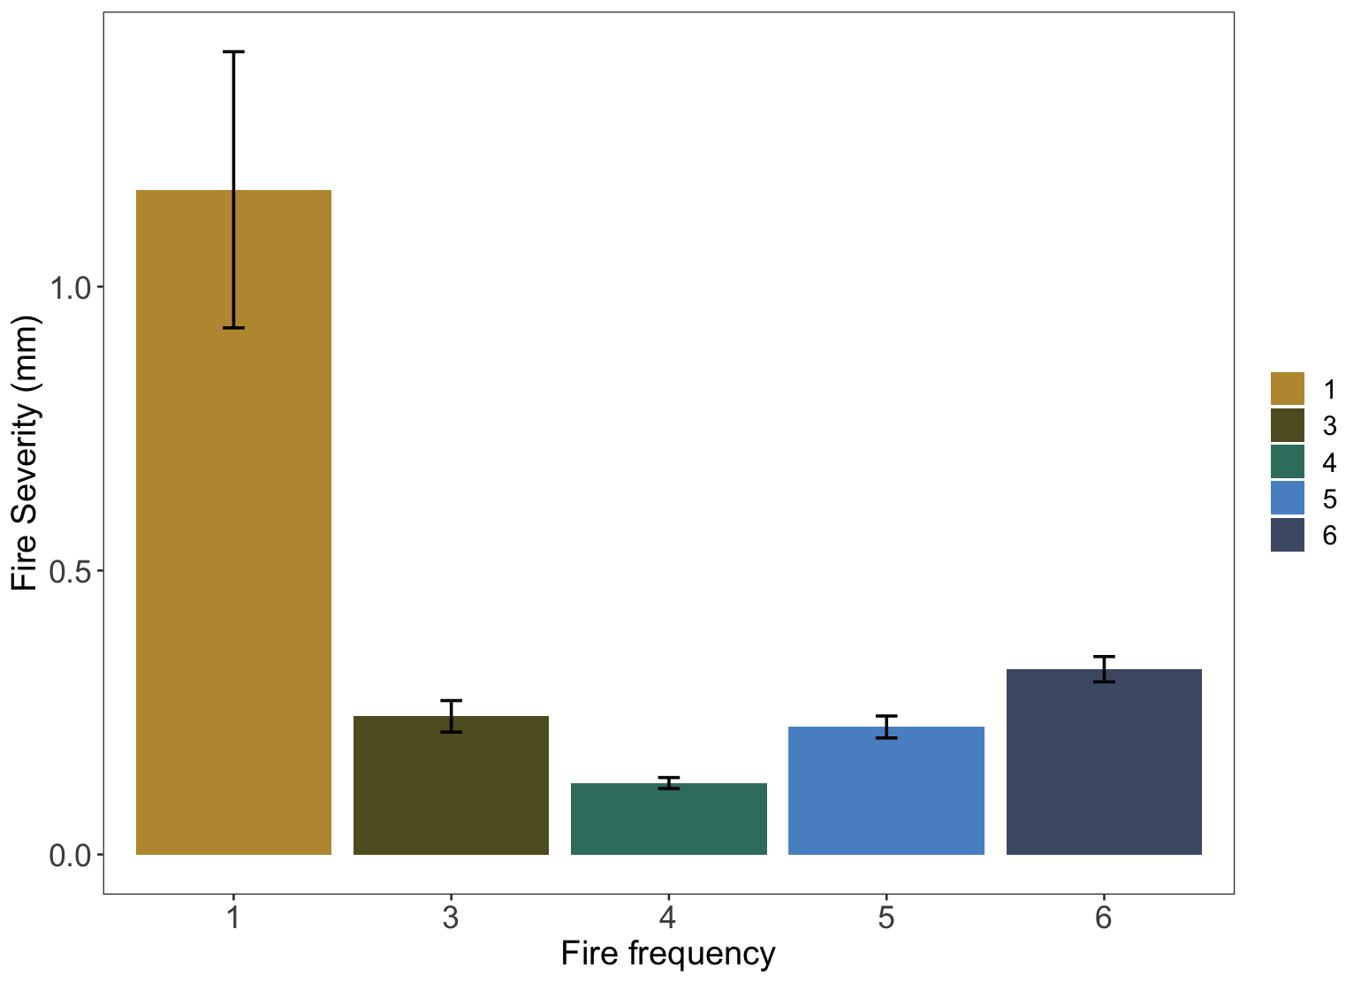

*Fig 2: Measures of mean fire severity (mm) (± SE) decrease with increased fire frequency.*

***Species cover, diversity, and composition (H1)***

In total, 223 species were found throughout the study area. As predicted, we found that the proportion of native species cover, the proportion of native richness, and the proportion of native Shannon diversity declined with increased fire recurrence in both survey years (Fig. 3). The effect of fire recurrence was strongest for the proportion of native cover (βnumburn = -1.17; CIs = -1.67 to -0.67) and moderately strong for the proportion of native species richness (βnumburn = -0.50; CIs = -0.86 to -0.15) and Shannon diversity (βnumburn = -0.65; CIs = -1.14 to -0.16) (Supplemental Table 1). The overall average marginal effect of a 1-unit increase in fire frequency decreased the proportion of native cover by 12%, the proportion of native richness by 4%, and the proportion of native Shannon diversity by 4%.

This effect of fire frequency, however, varied at higher and lower levels of fire frequency for all diversity metrics (Fig. 3). At lower levels of fire frequency, a one-unit increase in frequency led to a significant 16% decrease in the proportion of native cover (Fig. 3b). In contrast, a frequency of 5 fires in the past 30 years resulted in a 5% *increase* in the proportion of native cover. The pattern of native richness and Shannon diversity closely align with the findings for native cover. For lower levels of fire frequency, a one-unit increase is associated with a 7% and 9% decrease in native richness and Shannon diversity, respectively. However, as fire frequency rises to higher levels there is a noticeable shift to a 2% increase in native richness and a 1% increase in Shannon diversity.

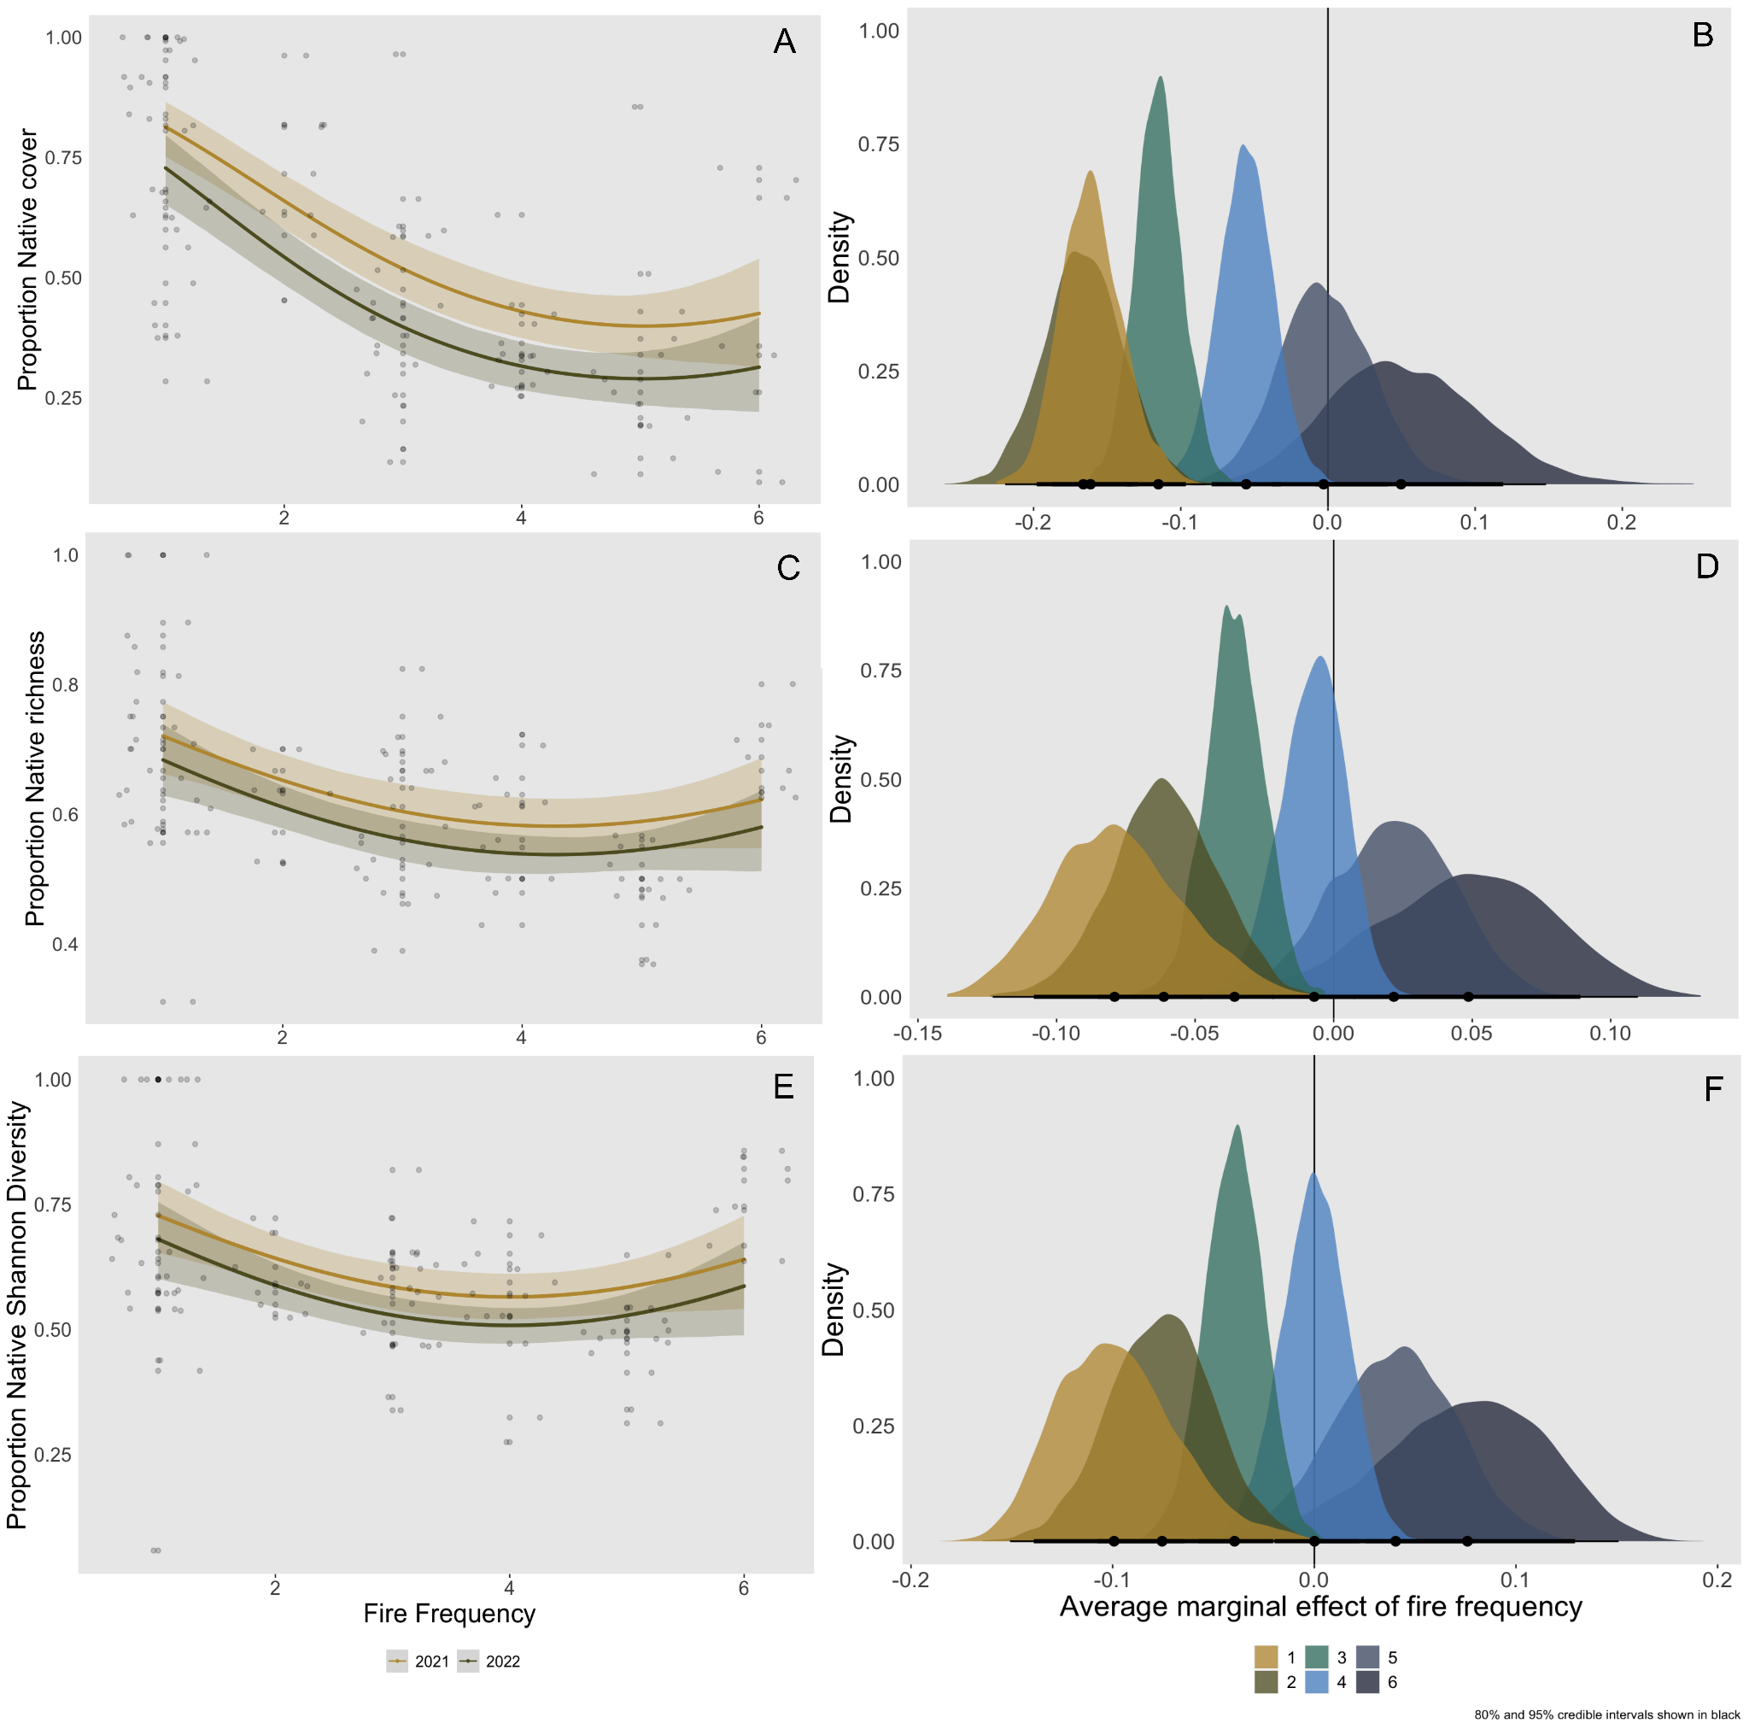

*Fig 3: Proportion of native species cover (A), richness (C), and Shannon diversity (E) at the plot level declines with increased fire frequency. Predicted values from the top-ranked Bayesian model with 95% credible intervals, as well as raw values (grey circles, n=103).*

Plots in areas with different fire frequencies had different species assemblages. The NMDS ordination of species composition resulted in an overlapping cluster of plots with higher fire recurrence (>2 short interval fires) that contain more non-native herbaceous species, while plots with lower fire recurrence (≤ 2 short interval fires) contained more native herbaceous species and shrubs (Fig. 4). Species characteristic of the high fire frequency plots included *Avena barbata*, *Centaurea melitensis,* *Erodium cicutarium*, and *Festuca myuros* (Fig. 4), all classic dominant species in the exotic annual grassland that characterizes highly disturbed sites in lowland California. Plots with higher fire recurrence had smaller clusters compared to areas with low fire recurrence, indicating a shift from a more heterogeneous post-fire landscape to a more homogeneous landscape with many similar non-native species.

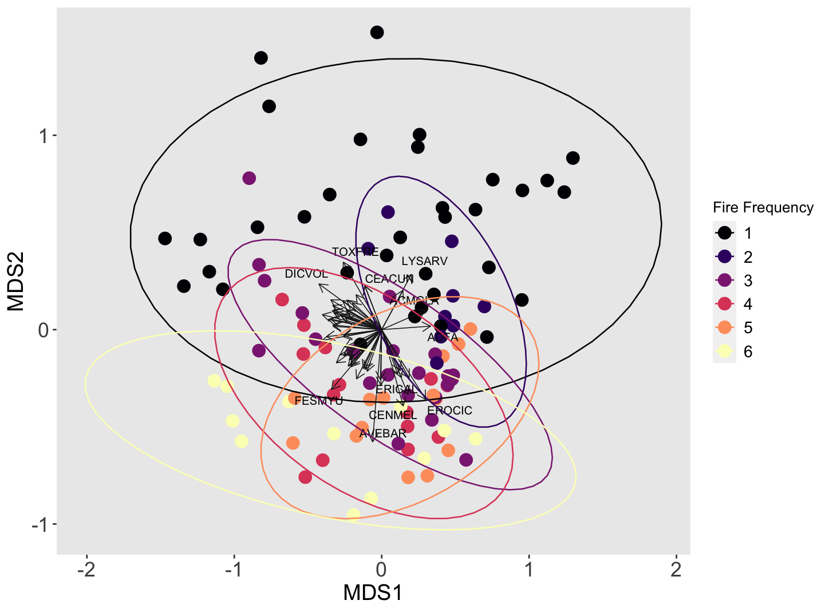

​​

*Fig 4: Non-metric multidimensional scaling plot (NMDS) of Bray-Curtis dissimilarity matrix across fire frequency. Each point represents a survey point. Plots with higher fire recurrence (pink, orange, and yellow) are more clustered together, indicating that they have a more similar species composition than plots with lower fire recurrence (black, dark blue, purple). Labeling priority was given to more abundant and frequent species. Species codes:* ACMGLA *Acmispon glaber,* ACMWRA *Acmispon wrangelianus,* ADFA *Adenostoma fasciculatum,* ASTGAM *Astragalus gambelianus,* AVEBAR *Avena barbata,* CEACUN *Ceanothus cuneatus,*CENMEL *Centaurea melitensis,* CLAUNG *Clarkia unguiculata,* DICVOL *Dichelostemma volubile,* ERICAL *Eriodictyon californicum,* EROCIC *Erodium cicutarium, ESCCAE Eschscholzia caespitosa,* FESMYU *Festuca myuros,* LYSARV *Lysimachia arvensis,* MELTOR *Melica torreyana,* NEMMEN *Nemophila menziesii,* STARIG *Stachys rigida,* TOXFRE *Toxicodendron fremontii,* TRIMIC *Trifolium microcephalum,* TRIMIC2 *Trifolum microdon. Final stress of three dimensional solution = 0.166 after 24 iterations.*

***Shrub regeneration (H2a)***

Increased fire frequency in northern California chamise chaparral reduced shrub seedling regeneration, as expected (Fig. 5). Overall, seedling regeneration of FS declined by 83% and OS regeneration declined by 99% in the most frequently burned plots (fire frequency = 6). OS species, including *Ceanothus oliganthus* and *Ceanothus cuneatus,* were almost completely eliminated in areas with >2 fires in the past 30 years (Fig. 5). We found a strong negative association between fire frequency and the presence of OS regeneration (βnumburn = -0.92; CIs = -1.43 to -0.49; Fig. 5a) and a significant, albeit less strong, negative association between fire frequency and the presence of FS regeneration (βnumburn = -0.33; CIs = -0.47 to -0.19; Fig. 6a). Fire frequency significantly reduced the presence of *Ceanthous cuneatus* (βnumburn = -1.10; CIs = -1.65 to -0.64; Fig. 5b) and *Ceanothus oliganthus* (βnumburn = -1.20; CIs = -2.27 to -0.41; Fig. 5c). The effect of fire frequency on FS regeneration was species-specific and significantly reduced the presence of *Adenostoma fasciculatum* (βnumburn = -0.70; CIs = -1.02 to -0.40; Fig. 6b) and *Lepechinia calycina* seedlings(βnumburn = -0.66; CIs = -1.00 to -0.35; Fig. 6d). Despite an overall decrease in presence of FS regeneration due to fire frequency, we found a slight qualitative increase in *Eriodictyon californicum* seedlings(βnumburn = 0.05; CIs = -0.18 to 0.28) but this effect was not significant (Fig. 6c).

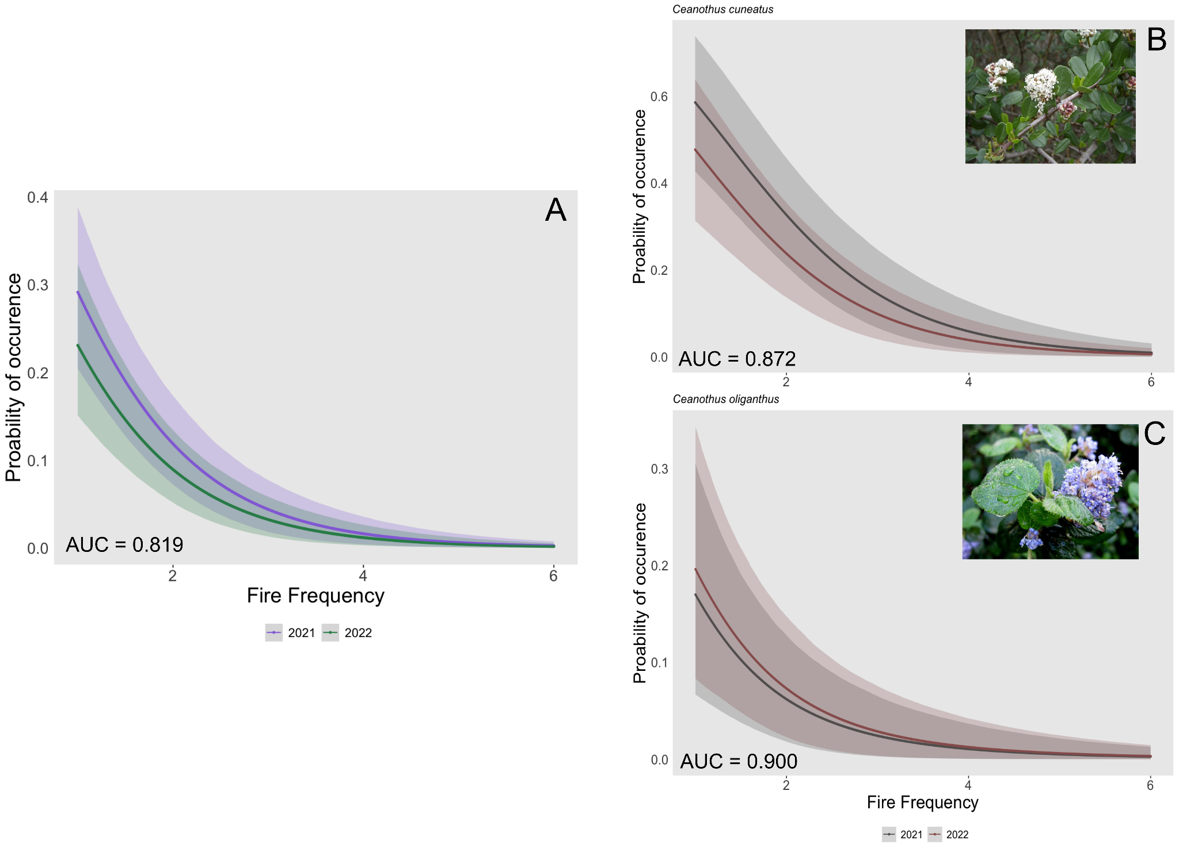

*Fig 5: The probability of occurrence of an obligate seedling (A), including Ceanothus cuneatus (B) and Ceanothus oliganthus (C), declines with increased fire frequency in both survey years (2021 & 2022). The probability of occurrence is the presence of at least one seedling in the 250m2 plot. Error bars show 95% CIs. The area under the receiver operating curve (AUC), a measure of model accuracy ranging from 0-1, noted in the bottom left.*

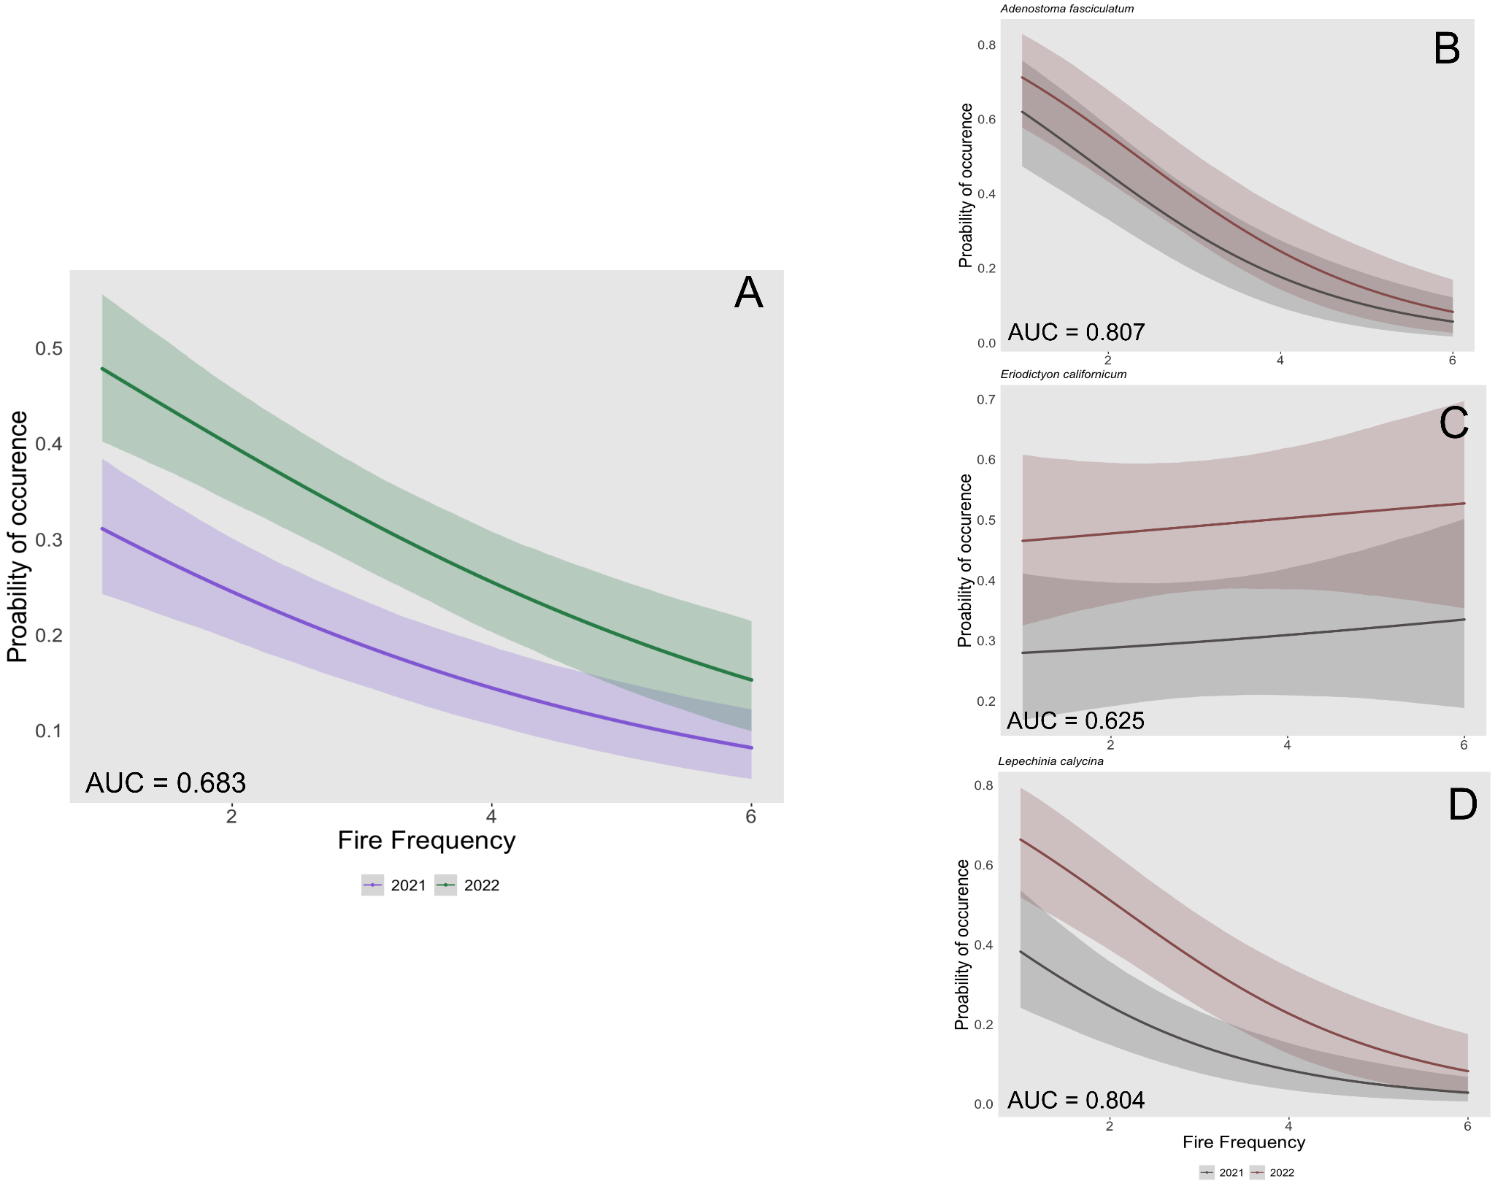

*Fig 6: The probability of occurrence of a facultative seedling (A) declines with increased fire frequency in both survey years (2021 & 2022). This relationship was species-dependent, and fire frequency had little change on the probability of occurrence of an Eriodictyon californicum seedling (C) but decreased the probability of occurrence for Adenostoma fasciculatum (B) and Lepechinia calycina (D) seedlings. The probability of occurrence is the presence of at least one seedling in the 250m2 plot. Error bars show 95% CIs. The area under the receiver operating curve (AUC), a measure of model accuracy ranging from 0-1, noted in the bottom left.*

***Shrub resprout growth (H2b)***

In contrast to hypothesis 2b, we did not see any significant difference in *A. fasciculatum* resprout growth with increased fire frequency (βnumburn = 0.00; CIs = -0.02 to 0.01; Fig. 7). Despite a reduction in live individuals, postfire height was around 0.4 meters 1-year after fire for all levels of fire frequency. Heat load index and the diameter of the largest stem improved model fit, but did not have a strong association with resprout growth (βhli = 0.00; CIs = -0.02 to 0.01; βdiam largest stem = -0.01; CIs = -0.03 to 0.00)

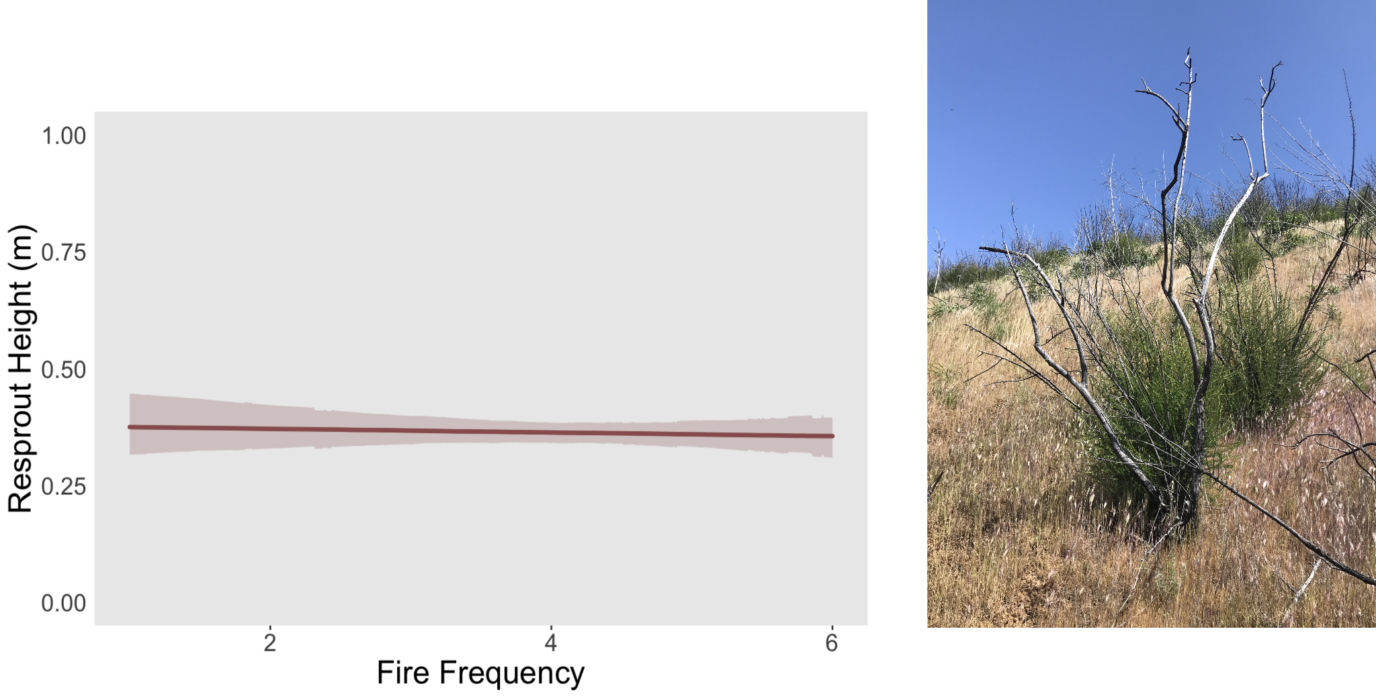

*Fig. 7: Resprout height (m) of Adenostoma fasciculatum does not significantly change with increased fire frequency. Error bars show 95% CIs.*

# Discussion

Our results are consistent with other studies that show a reduction in native shrub regeneration and species diversity after multiple, short-interval fires in chaparral shrublands [(Zedler et al. 1983, Haidinger and Keeley 1993, Jacobsen et al. 2004, Keeley and Brennan 2012)](https://www.zotero.org/google-docs/?fwR8j7). Yet our study is the first to examine how such high fire frequencies – up to six times in the past 30 years – may be impacting chaparral vegetation in northern California. Our findings highlight how uncharacteristically high fire recurrence in northern California chaparral reduced fire severity, resulting in a reduction in native woody regeneration and biotic homogenization by replacing unique native species with non-native annual species. Overall, these results highlight the complex relationship between fire frequency and diversity metrics, showcasing how different levels of fire frequency can impact native cover, richness, and Shannon diversity in varying ways.

It is important to note that the occurrence of short intervals between fires, rather than fire frequency per se, is a key component to type conversion [(Jacobsen et al. 2004, Syphard et al. 2019)](https://www.zotero.org/google-docs/?aBtQ8j). Our study examines the effect of fire frequency, and because short interval fires are more likely to occur when fire is more frequent, we can not parse a part causality between the two in this study. Short fire return intervals reduce fire intensity, promoting non-native species persistence and reducing regeneration of native chaparral shrubs (Keeley et al. 2006). This has severe consequences for obligate seeding shrubs that require at least 10 years to mature before replenishing the seed bank (Zedler et al. 1983; Jacobson et al. 2004). Despite our inability to parse the importance of fire return interval and fire frequency independently, assessing fire frequency by itself is still relevant given the increasingly common condition of frequent fire in chaparral and that the two are very often linked.

***How does fire frequency affect the diversity and cover of native and non-native species?***

Our study confirms that increased fire frequency facilitates a reduction in the proportion of native species cover, richness, and Shannon diversity. Consequently, plots with higher fire recurrence exhibit a more homogeneous landscape, dominated by similar non-native species. This result is in line with the vast body of research in southern California, showing that high fire frequency, and subsequent short fire intervals, promote non-native invasion [(Keeley et al. 2006, Syphard et al. 2019)](https://www.zotero.org/google-docs/?z8wzbt). It is generally known that in chaparral landscapes, shrub canopy closure and the presence of a non-native seedbank at the time of fire are important drivers of non-native invasion [(D’Antonio et al. 2001, D’Antonio and Kark 2002, Keeley et al. 2005)](https://www.zotero.org/google-docs/?0Te2K2). We observed a decrease in fire severity with an increase in fire frequency. This lower intensity fire removes filters that kill the non-native species pool and promotes native germination [(Keeley et al. 2008, Keeley and Brennan 2012)](https://www.zotero.org/google-docs/?Q8mYQl).

Prior studies have focused on southern California and have only examined the impacts of up to three short-interval fires. Our study is the first to show the effect of up to six fires in the past 30 years. Note that at the most highly departed sites (FF=6), there is a slight increase in the proportion of all diversity metrics. This is a result we were not necessarily expecting and is likely due to a transition to grassland vegetation type. Highly departed sites are primarily dominated by non-native grasses and fobs (e.g., *Avena barbata, Bromus madritensis, Erodium sp.*). Nonetheless, we found a slight increase in native richness and cover at the higher end of the fire frequency gradient (>5 fires in the past 30 years), driven mostly by disturbance-tolerant native species that are common in California grassland systems (e.g., *Acmispon sp., Madia sp., Dichelostemma sp.).* Despite this increase in native forbs, we observed no perennial grasses characteristic of native California grasslands at these sites (e.g., *Stipa pulchra, Festuca idahoensis*). Further, these plots still exhibited lower diversity metrics than sites with lower fire frequency (<2 fires in the past 30 years).

***What are the consequences of higher burn frequency on shrub seedling establishment and resprouting success?***

As predicted, we found a reduction in both OS and FS regeneration. OS species, such as *C. oliganthus* and *C. cuneatus,* were almost completely eliminated in areas with more than 2 fires in the past 30 years (99% reduction). These results are consistent with other studies in southern California, showing that obligate seeding shrubs often require a decade or more to reach maturity and replenish the seedbank [(Zedler et al. 1983, Jacobsen et al. 2004, Keeley and Brennan 2012)](https://www.zotero.org/google-docs/?k48ZWx). Our observed reduction in fire severity with short-interval fires confirm a departure from the high-intensity fires that are historic for chamise-dominated chaparral and vital for the survival and recruitment of many chaparral shrub species (Park and Jenerette, 2019).

Facultative species also declined with high fire frequency (83% reduction), however, this relationship was species-dependent and we found a shift from *A. fasciculatum* to *E. californicum* seedling presence. We found that *A. fasciculatum* re-established well from seedlings after up to 3 fires in the past 30 years. Still, seedling regeneration declined and was almost completely eliminated in areas with high fire frequency (FF=5). This result contrasts with research in southern California, reporting a drastic reduction in *A. fasciculatum* seedlings after just two short interval fires [(Zedler et al. 1983, Keeley and Brennan 2012)](https://www.zotero.org/google-docs/?n7pAur).

Despite our prediction that all facultative seeding species regeneration would be eliminated after 2 short interval fires, there was little effect on *Eriodictyon californicum* regeneration. We found a slight increase in seedling regeneration at the most highly departed sites. This is not all surprising, considering *Eriodictyon sp.* is a principal invader in many disturbed sites [(Mooney and Hobbs 1986)](https://www.zotero.org/google-docs/?yt0VYg). While grouping regeneration by functional type (OS, FS) can be very useful, species-specific responses are vital to consider [(Keeley et al. 2006)](https://www.zotero.org/google-docs/?caSxSC). While all obligate seeding species declined with high fire frequency, facultative species as a group showed reduced regeneration but displayed species-specific responses, with some species persisting at high levels of fire frequency.

Contrary to our expectations, and findings from research in southern California [(Zedler et al. 1983, Keeley and Brennan 2012)](https://www.zotero.org/google-docs/?mQrLOp), we found no reduction in resprout growth with increased fire frequency. This may be due, in part, to other variables that play an essential role in determining the vigor of resprouting shrubs. For example, the survival and vigor of resprouting shrubs in northern California are especially sensitive to pre-fire drought and can exacerbate the effect of short-interval fire [(Werner et al. 2022)](https://www.zotero.org/google-docs/?x1GjIS). While the lack of environmental variation (e.g., temperature, precipitation) and temporal scope across our sites makes it difficult to parse out the exact cause of reduced resprout vigor, we can fully understand the consequences of increased fire frequency, which did not have a strong impact on resprout vigor. While resprouting species are well adapted for repeat fires, they can be extirpated after some time (Zedler et al. 1983, Keeley and Brennan 2012). Assessing shrub mortality, in addition to resprout success, is vital to consider.

**Conclusion**

Much of the species diversity in California – a global biodiversity hotspot – is centered in chaparral-dominated shrublands. There is a rich diversity of endemic species restricted to chaparral and loss of this habitat type has major implications on many ecosystem services such as flood control, carbon sequestration, nutrient cycling, pollination, primary production, and habitat provision [(Rundel 2018, Underwood et al. 2018)](https://www.zotero.org/google-docs/?aHRgs6). Here we provide valuable insights into the effects of altered fire regimes on chaparral plant communities.Our study demonstrates that increased fire frequency, and subsequent short fire return intervals, precipitate a substantive shift from a distinctive assemblage of unique native species to a homogenized community dominated by non-native species. Areas dominated by nonnative grasses increase fine fuel loads, leading to more frequent fires that burn at lower intensity. This shift in fire behavior allows the nonnative seedbank to persist, perpetuating the cycle. Once a community has undergone type conversion, it has a very low chance of reverting back to its historical condition, even if actively managed. Identifying areas that are in severe danger of type conversion, but are still intact, opens the possibility for preventative management. Specifically, supporting the need for controlling unplanned ignitions in chaparral (Safford et al. 2018) or exploring other management alternatives.

**Acknowledgments**

Many thanks to Sam Vaillancourt, Marcela Cathcart, and Reed Kenny for field support, Andrew Latimer and Hannah Fertel for general analysis advice, and Sara Winsemius for reviewing this manuscript. We thank Shane Waddell, the University of California Natural Reserve System, and the U.S. Bureau of Land Management for access to study sites. Funding was provided by CAL FIRE (8GG20807) and the UC Davis Jastro-Shields Graduate Research Award.

# Literature Cited

[Abatzoglou, J. T., and A. P. Williams. 2016. Impact of anthropogenic climate change on wildfire across western US forests. Proceedings of the National Academy of Sciences 113:11770–11775.](https://www.zotero.org/google-docs/?j8TaF2)

[Anderson, M. K., and J. E. Keeley. 2018. Native Peoples’ Relationship to the California Chaparral. Pages 79–121 *in* E. C. Underwood, H. D. Safford, N. A. Molinari, and J. E. Keeley, editors. Valuing Chaparral: Ecological, Socio-Economic, and Management Perspectives. Springer International Publishing, Cham.](https://www.zotero.org/google-docs/?j8TaF2)

[Bürkner, P.-C. 2017. brms: An *R* Package for Bayesian Multilevel Models Using *Stan*. Journal of Statistical Software 80.](https://www.zotero.org/google-docs/?j8TaF2)

[Callaway, R. M., and F. W. Davis. 1993. Vegetation Dynamics, Fire, and the Physical Environment in Coastal Central California. Ecology 74:1567–1578.](https://www.zotero.org/google-docs/?j8TaF2)

[Cayan, D. R., E. P. Maurer, M. D. Dettinger, M. Tyree, and K. Hayhoe. 2008. Climate change scenarios for the California region. Climatic Change 87:21–42.](https://www.zotero.org/google-docs/?j8TaF2)

[D’Antonio, C., J. Levine, M. Thomsen, and others. 2001. Ecosystem resistance to invasion and the role of propagule supply: a California perspective. Journal of Mediterranean Ecology 2:233–246.](https://www.zotero.org/google-docs/?j8TaF2)

[D’Antonio, C. M., and S. Kark. 2002. Impacts and extent of biotic invasions in terrestrial ecosystems. Trends in Ecology & Evolution 17:202–204.](https://www.zotero.org/google-docs/?j8TaF2)

[D’Antonio, C. M., and P. M. Vitousek. 1992. Biological Invasions by Exotic Grasses, the Grass/Fire Cycle, and Global Change. Annual Review of Ecology and Systematics 23:63–87.](https://www.zotero.org/google-docs/?j8TaF2)

[Flannigan, M. D., B. J. Stocks, and B. M. Wotton. 2000. Climate change and forest fires. Science of The Total Environment 262:221–229.](https://www.zotero.org/google-docs/?j8TaF2)

[Fried, J. S., M. S. Torn, and E. Mills. 2004. The Impact of Climate Change on Wildfire Severity: A Regional Forecast for Northern California. Climatic Change 64:169–191.](https://www.zotero.org/google-docs/?j8TaF2)

[Haidinger, T. L., and J. E. Keeley. 1993. Role of High Fire Frequency in Destruction of Mixed Chaparral. Madroño 40:141–147.](https://www.zotero.org/google-docs/?j8TaF2)

[He, T., B. B. Lamont, and J. G. Pausas. 2019. Fire as a key driver of Earth’s biodiversity. Biological Reviews 94:1983–2010.](https://www.zotero.org/google-docs/?j8TaF2)

[Jacobsen, A., S. Davis, and S. Fabritius. 2004. Fire frequency impacts non-sprouting chaparral shrubs in the Santa Monica Mountains of southern California. Ecology, conservation and management of mediterranean climate ecosystems. Millpress, Rotterdam, Netherlands.](https://www.zotero.org/google-docs/?j8TaF2)

[Keeley, J. E., M. Baer-Keeley, and C. J. Fotheringham. 2005. Alien plant dynamics following fire in Mediterranean‐climate California shrublands. Ecological Applications 15:2109–2125.](https://www.zotero.org/google-docs/?j8TaF2)

[Keeley, J. E., and T. J. Brennan. 2012. Fire-driven alien invasion in a fire-adapted ecosystem. Oecologia 169:1043–1052.](https://www.zotero.org/google-docs/?j8TaF2)

[Keeley, J. E., T. Brennan, and A. H. Pfaff. 2008. Fire Severity and Ecosytem Responses Following Crown Fires in California Shrublands. Ecological Applications 18:1530–1546.](https://www.zotero.org/google-docs/?j8TaF2)

[Keeley, J. E., and C. J. Fotheringham. 2001. Historic Fire Regime in Southern California Shrublands. Conservation Biology 15:1536–1548.](https://www.zotero.org/google-docs/?j8TaF2)

[Keeley, J. E., and C. J. Fotheringham. 2003. Impact of Past, Present, and Future Fire Regimes on North American Mediterranean Shrublands. Pages 218–262 *in* T. T. Veblen, W. L. Baker, G. Montenegro, and T. W. Swetnam, editors. Fire and Climatic Change in Temperate Ecosystems of the Western Americas. Springer, New York, NY.](https://www.zotero.org/google-docs/?j8TaF2)

[Keeley, J. E., C. J. Fotheringham, and M. Baer-Keeley. 2006. Demographic Patterns of Postfire Regeneration in Mediterranean-Climate Shrublands of California. Ecological Monographs 76:235–255.](https://www.zotero.org/google-docs/?j8TaF2)

[Keeley, J. E., and H. D. Safford. 2016. Fire as an ecosystem process: Chapter 3.](https://www.zotero.org/google-docs/?j8TaF2)

[McCune, B., and D. Keon. 2002. Equations for potential annual direct incident radiation and heat load. Journal of Vegetation Science 13:603–606.](https://www.zotero.org/google-docs/?j8TaF2)

[McLauchlan, K. K., P. E. Higuera, J. Miesel, B. M. Rogers, J. Schweitzer, J. K. Shuman, A. J. Tepley, J. M. Varner, T. T. Veblen, S. A. Adalsteinsson, J. K. Balch, P. Baker, E. Batllori, E. Bigio, P. Brando, M. Cattau, M. L. Chipman, J. Coen, R. Crandall, L. Daniels, N. Enright, W. S. Gross, B. J. Harvey, J. A. Hatten, S. Hermann, R. E. Hewitt, L. N. Kobziar, J. B. Landesmann, M. M. Loranty, S. Y. Maezumi, L. Mearns, M. Moritz, J. A. Myers, J. G. Pausas, A. F. A. Pellegrini, W. J. Platt, J. Roozeboom, H. Safford, F. Santos, R. M. Scheller, R. L. Sherriff, K. G. Smith, M. D. Smith, and A. C. Watts. 2020. Fire as a fundamental ecological process: Research advances and frontiers. Journal of Ecology 108:2047–2069.](https://www.zotero.org/google-docs/?j8TaF2)

[Miller, J. E. D., A. M. Weill, and J. Villella. 2022. Epiphytic macrolichen communities take decades to recover after high-severity wildfire in chaparral shrublands. Diversity and Distributions 28:454–462.](https://www.zotero.org/google-docs/?j8TaF2)

[Mooney, H. A., and R. J. Hobbs. 1986. Resilience at the individual plant level. Pages 65–82 *in* B. Dell, A. J. M. Hopkins, and B. B. Lamont, editors. Resilience in mediterranean-type ecosystems. Springer Netherlands, Dordrecht.](https://www.zotero.org/google-docs/?j8TaF2)

[Oksanen, J., G. L. Simpson, F. G. Blanchet, R. Kindt, P. Legendre, P. R. Minchin, R. B. O’Hara, P. Solymos, M. H. H. Stevens, E. Szoecs, H. Wagner, M. Barbour, M. Bedward, B. Bolker, D. Borcard, G. Carvalho, M. Chirico, M. D. Caceres, S. Durand, H. B. A. Evangelista, R. FitzJohn, M. Friendly, B. Furneaux, G. Hannigan, M. O. Hill, L. Lahti, D. McGlinn, M.-H. Ouellette, E. R. Cunha, T. Smith, A. Stier, C. J. F. T. Braak, and J. Weedon. 2023. vegan: Community Ecology Package.](https://www.zotero.org/google-docs/?j8TaF2)

[Park, I. W., J. Hooper, J. M. Flegal, and G. D. Jenerette. 2018. Impacts of climate, disturbance and topography on distribution of herbaceous cover in Southern California chaparral: Insights from a remote-sensing method. Diversity and Distributions 24:497–508.](https://www.zotero.org/google-docs/?j8TaF2)

[Park, I. W., and G. D. Jenerette. 2019. Causes and feedbacks to widespread grass invasion into chaparral shrub dominated landscapes. Landscape Ecology 34:459–471.](https://www.zotero.org/google-docs/?j8TaF2)

[Pausas, J. G., R. A. Bradstock, D. A. Keith, and J. E. Keeley. 2004. Plant Functional Traits in Relation to Fire in Crown-Fire Ecosystems. Ecology 85:1085–1100.](https://www.zotero.org/google-docs/?j8TaF2)

[Perez, B., and J. M. Moreno. 1998. Methods for quantifying fire severity in shrubland-fires. Plant Ecology 139:91–101.](https://www.zotero.org/google-docs/?j8TaF2)

[Potts, J. B., E. Marino, and S. L. Stephens. 2010. Chaparral shrub recovery after fuel reduction: a comparison of prescribed fire and mastication techniques. Plant Ecology 210:303–315.](https://www.zotero.org/google-docs/?j8TaF2)

PRISM Climate Group, Oregon State University, https://prism.oregonstate.edu, data created 4 Feb 2014, accessed 15 December 2022

[R Core Team. 2021. R: A Language and Environment for Statistical Computing. R Foundation for Statistical Computing, Vienna, Austria.](https://www.zotero.org/google-docs/?j8TaF2)

[Raunkiaer, C. 1934. The life forms of plants and statistical plant geography; being the collected papers of C. Raunkiær. The life forms of plants and statistical plant geography; being the collected papers of C. Raunkiaer.](https://www.zotero.org/google-docs/?j8TaF2)

[Rundel, P. W. 2018. California Chaparral and Its Global Significance. Pages 1–27 *in* E. C. Underwood, H. D. Safford, N. A. Molinari, and J. E. Keeley, editors. Valuing Chaparral. Springer International Publishing, Cham.](https://www.zotero.org/google-docs/?j8TaF2)

[Safford, H. D., R. J. Butz, G. N. Bohlman, M. Coppoletta, B. L. Estes, S. E. Gross, K. E. Merriam, M. D. Meyer, N. A. Molinari, and A. Wuenschel. 2021. Fire Ecology of the North American Mediterranean-Climate Zone. Pages 337–392 *in* C. H. Greenberg and B. Collins, editors. Fire Ecology and Management: Past, Present, and Future of US Forested Ecosystems. Springer International Publishing, Cham.](https://www.zotero.org/google-docs/?j8TaF2)

[Safford, H. D., and S. Harrison. 2004. Fire effects on plant diversity in serpentine vs. sandstone chaparral. Ecology 85:539–548.](https://www.zotero.org/google-docs/?j8TaF2)

[Safford, H. D., A. K. Paulson, Z. L. Steel, D. J. N. Young, and R. B. Wayman. 2022. The 2020 California fire season: A year like no other, a return to the past or a harbinger of the future? Global Ecology and Biogeography 31:2005–2025.](https://www.zotero.org/google-docs/?j8TaF2)

Safford, H.D., Underwood, E.C., Molinari, N.A., 2018. Managing Chaparral Resources on Public Lands, in: Underwood, E.C., Safford, H.D., Molinari, N.A., Keeley, J.E. (Eds.), Valuing Chaparral: Ecological, Socio-Economic, and Management Perspectives, Springer Series on Environmental Management. Springer International Publishing, Cham, pp. 411–448. https://doi.org/10.1007/978-3-319-68303-4_15

[Sing, T., O. Sander, N. Beerenwinkel, and T. Lengauer. 2005. ROCR: visualizing classifier performance in R. Bioinformatics 21:3940–3941.](https://www.zotero.org/google-docs/?j8TaF2)

[Syphard, A. D., T. J. Brennan, and J. E. Keeley. 2019. Drivers of chaparral type conversion to herbaceous vegetation in coastal Southern California. Diversity and Distributions 25:90–101.](https://www.zotero.org/google-docs/?j8TaF2)

[Syphard, A. D., J. Franklin, and J. E. Keeley. 2006. Simulating the Effects of Frequent Fire on Southern California Coastal Shrublands. Ecological Applications 16:1744–1756.](https://www.zotero.org/google-docs/?j8TaF2)

[Syphard, A. D., and J. E. Keeley. 2015. Location, timing and extent of wildfire vary by cause of ignition. International Journal of Wildland Fire 24:37.](https://www.zotero.org/google-docs/?j8TaF2)

[Underwood, E. C., H. D. Safford, N. A. Molinari, and J. E. Keeley, editors. 2018. Valuing Chaparral: Ecological, Socio-Economic, and Management Perspectives. Springer International Publishing, Cham.](https://www.zotero.org/google-docs/?j8TaF2)

[Van de Water, K. M., and H. D. Safford. 2011. A Summary of Fire Frequency Estimates for California Vegetation before Euro-American Settlement. Fire Ecology 7:26–58.](https://www.zotero.org/google-docs/?j8TaF2)

[Werner, C. M., S. P. Harrison, H. D. Safford, G. N. Bohlman, and R. Serata. 2022. Extreme pre-fire drought decreases shrub regeneration on fertile soils. Ecological Applications 32:e02464.](https://www.zotero.org/google-docs/?j8TaF2)

[Zedler, P. H., C. R. Gautier, and G. S. McMaster. 1983. Vegetation Change in Response to Extreme Events: The Effect of a Short Interval between Fires in California Chaparral and Coastal Scrub. Ecology 64:809–818.](https://www.zotero.org/google-docs/?j8TaF2)

# Supplemental Figures

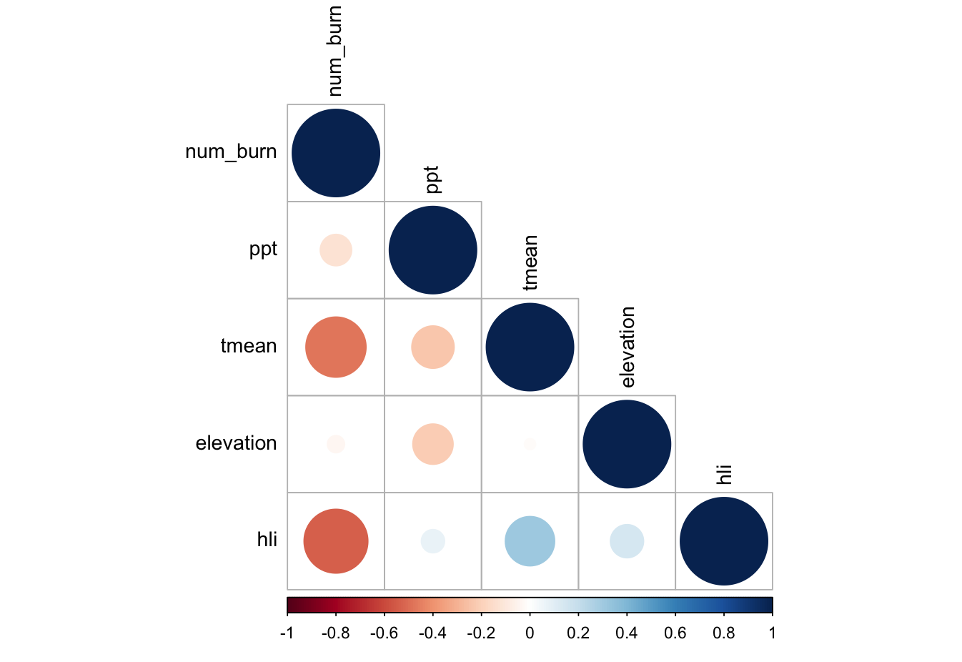

*Supplemental Figure 1: Correlation plot of covariates included in this analysis. Spearman’s Rank Correlation Coefficients*

*Supplemental Table 1: Model summary for Bayesian model fit for the proportion of native species cover, proportion of native species richness, and proportion of native Shannon diversity.*

|  |  |  |  |  |  |  |
| --- | --- | --- | --- | --- | --- | --- |
| **Native Species Cover** | Estimate | Est.Error | Lower 95% CI | Upper 95% CI | Rhat | Bulk_ESS |
| Intercept | 2.54 | 0.42 | 1.72 | 3.33 | 1.00 | 2335 |
| Num_burn | -1.17 | 0.26 | -1.67 | -0.67 | 1.00 | 2165 |
| Num_burn2 | 0.12 | 0.04 | 0.04 | 0.19 | 1.00 | 2200 |
| 2022 SurveyYear | -0.49 | 0.17 | -0.83 | -0.16 | 1.00 | 4612 |

|  |  |  |  |  |  |  |
| --- | --- | --- | --- | --- | --- | --- |
| **Native Species Richness** | Estimate | Est.Error | Lower 95% CI | Upper 95% CI | Rhat | Bulk_ESS |
| Intercept | 1.39 | 0.30 | 0.81 | 1.98 | 1.00 | 1596 |
| Num_burn | -0.50 | 0.18 | -0.86 | -0.15 | 1.00 | 1484 |
| Num_burn2 | 0.06 | 0.03 | 0.01 | 0.11 | 1.00 | 1439 |
| 2022 SurveyYear | -0.18 | 0.11 | -0.40 | 0.04 | 1.00 | 2856 |

|  |  |  |  |  |  |  |
| --- | --- | --- | --- | --- | --- | --- |
| **Native Shannon Diversity** | Estimate | Est.Error | Lower 95% CI | Upper 95% CI | Rhat | Bulk_ESS |
| Intercept | 1.56 | 0.41 | 0.77 | 2.40 | 1.00 | 2615 |
| Num_burn | -0.65 | 0.25 | -1.14 | -0.16 | 1.00 | 2523 |
| Num_burn2 | 0.08 | 0.04 | 0.01 | 0.15 | 1.00 | 2535 |
| 2022 SurveyYear | -0.23 | 0.13 | -0.49 | 0.02 | 1.00 | 6148 |